Name : Tushar Pathak
Registration Number : 230905396
Roll Number : CSE6B-48
Week Num : 2

LAB 2 : PRELIMINARY SCANNING APPLICATIONS
Q1) That takes a file as input and replaces blank spaces and tabs by single space and writes the output to a file.
Code:
#include <stdio.h>

int main() {
FILE *fp1, *fp2;
char ch;
int space = 0;

fp1 = fopen("testQ1.txt", "r");
fp2 = fopen("outputQ1.txt", "w");

while ((ch = fgetc(fp1)) != EOF) {
if (ch == ' ' || ch == '\t') {
if (space == 0) {
fputc(' ', fp2);
space = 1;
}
} else {
fputc(ch, fp2);
space = 0;
}
}

fclose(fp1);
fclose(fp2);

printf("Spaces and tabs replaced successfully\n");
return 0;
}

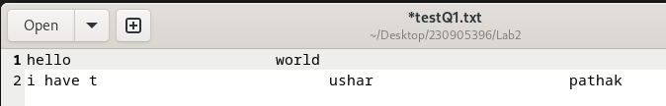
Input File:

Output file:
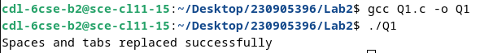
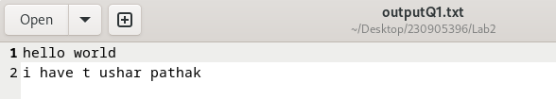

Q2) To discard preprocessor directives from the given input ‘C’ file.

Code :
#include <stdio.h>

int main() {
FILE *fp1, *fp2;
char line[200];

fp1 = fopen("inputQ2.c", "r");
fp2 = fopen("outputQ2.c", "w");

while (fgets(line, sizeof(line), fp1)) {
if (line[0] != '#') {
fputs(line, fp2);
}
}

fclose(fp1);
fclose(fp2);

printf("Preprocessor directives removed\n");
return 0;
}

Input File :
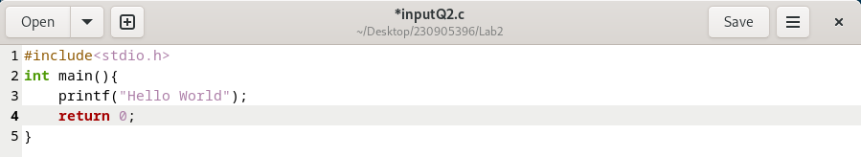

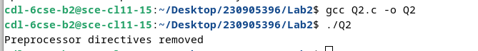
Output And New File :
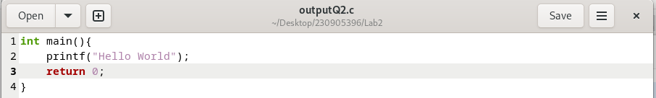

Q3) That takes C program as input, recognizes all the keywords and prints them in upper case.

Code:

#include <stdio.h>
#include <string.h>
#include <ctype.h>

char keywords[][10] = {
"int", "float", "char", "if", "else",
"for", "while", "return", "void"
};

int isKeyword(char *word) {
int i;
for (i = 0; i < 9; i++) {
if (strcmp(word, keywords[i]) == 0)
return 1;
}
return 0;
}

void toUpper(char *word) {
int i;
for (i = 0; word[i]; i++)
word[i] = toupper(word[i]);
}

int main() {
FILE *fp;
char word[50];

fp = fopen("inputQ3.c", "r");
printf("Keywords in UPPER CASE:\n");

while (fscanf(fp, "%s", word) != EOF) {
if (isKeyword(word)) {
toUpper(word);
printf("%s\n", word);
}
}

fclose(fp);
return 0;
}

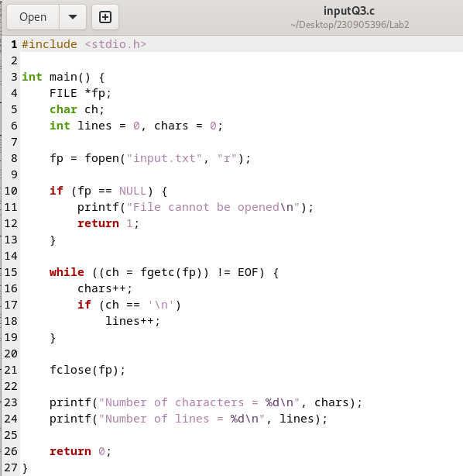
Input File :

Output :

